**IST 659 LAB Assignment 3**

**Problem 1:**  To come up with improved consumer selective advertisement strategies, AT&T wants to start maintaining a call log of which of its customers called which of its other customers. Each customer may call any number of other customers. The call log records the caller IDs of the consumers who dialed a call and caller IDs of consumers who received a call. The call log also records the call’s time, date and duration.

**Business Rules**

* Each customer can call as many number of customers
* Each customer can receive as many number of calls from customer

**ERD**

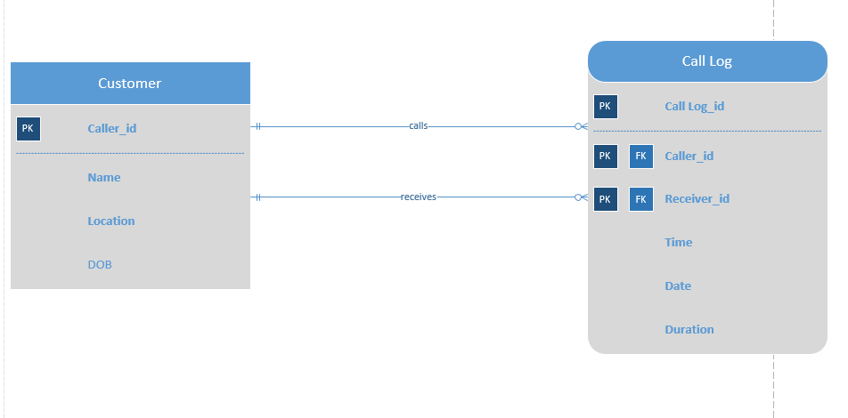

**Datasheet View of each table**

Customer Table

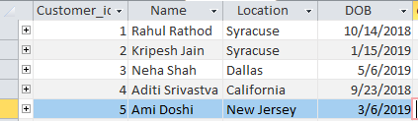

Call Log Table

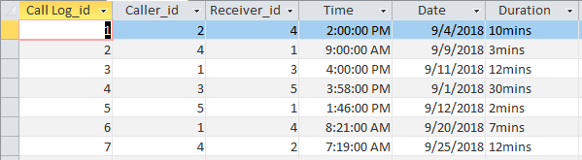

Data relationship model in Access

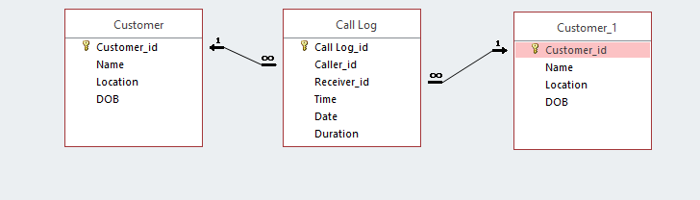

**Assumption:**

One caller can make no or multiple calls to other callers

One caller can receive no or multiple calls

**Problem 2:** Below is an example of a ternary relationship: Doctor prescribes medicines for patients. Please create a different ternary relationship on your own, model it, and create the database tables.

**Business Rules**

* Each Bar can sell at least one beer and each beer can be sold by at least one bar.

**ERD**

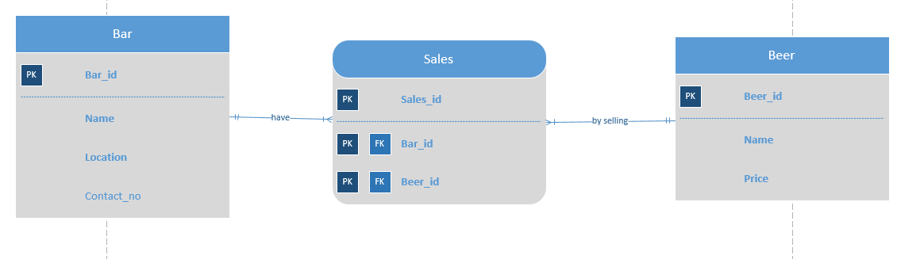

**Datasheet view of each table**

Bar table

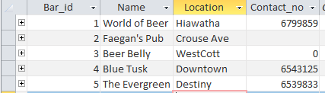

Beer table

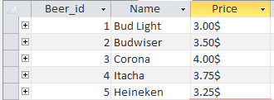

Sales table

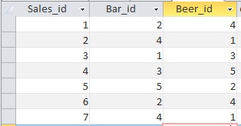

Data relationship in Access

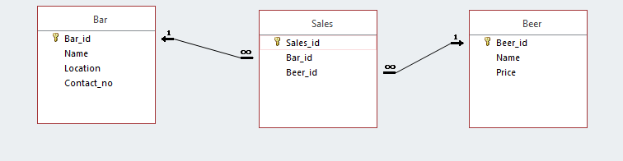

**Assumption:**

One bar sells at least one beer.

One beer is sold by at least one bar.